 | || ;тǒт, Gǐт;тǒт uтGNт nт¸nтMnwтr yттMnттzI GwтxтNт»`nттr || – iSaxaNamahYaI- Da^. baapUǐaI saaLuMKo  ēтI nǐттmтI Gǐтǐт<wтǒтMz GwтxтNт nтMnqтт, wт<lwт»Ur nтMcтGlтt  Dr. Bapuji Salunkhe Institute of Engineering & Technology 2130, Tarabai Park, Kolhapur – 416 003  Telephone: 0231-2658613, Web: www.bsiet.org

1 | Name of Faculty | Dr. Abhijeet Prakash Redekar |  | 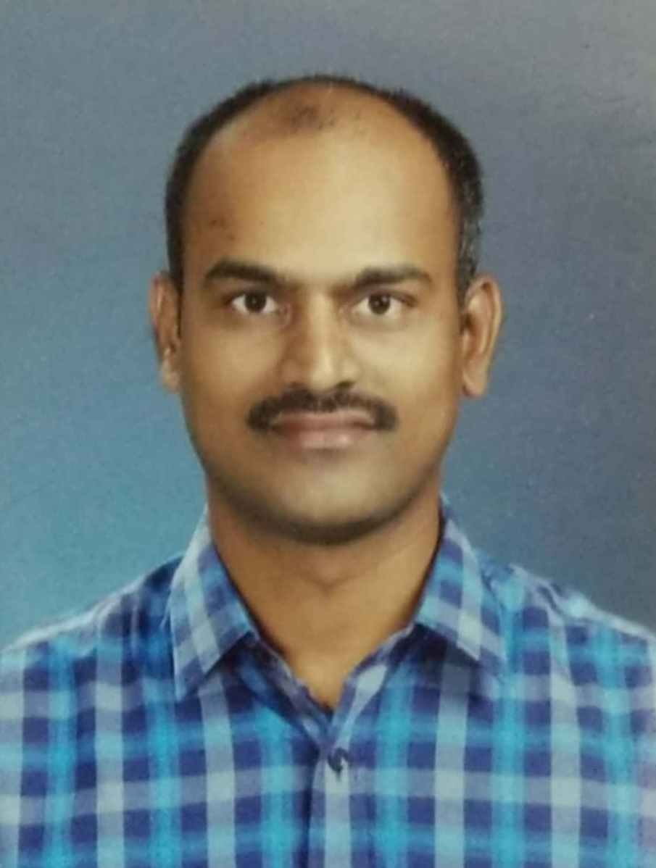
2 | Designation | Assistant Professor
4 | Date of Joining the Institute | 23/06/2025
5 | Contact No. | 9764891818
6 | E-mail | abhijeetredekar@bsiet.org
7 | Date of Birth | 01/08/1983
8 | Specialization | Power System
9 | Qualification | UG | PG |  | Ph.D.
 |  | B.E. | M.E. (Control system) |  | Control system
10 | Total Experience | Academic | Industrial |  | Total
 |  | 15 | 03 |  | 18
11 | Publications (Journals) | National | International
 |  | 00 | 07 |  | --
12 | Publications (Conferences) | National | International |  | Total
 |  | 03 | 02 |  | 10
13 | PG/Ph.D. Projects Guided | PG Projects | Ph.D. Projects |  | Total
 |  | -- | -- |  | --
14 | Books Published/IPRs/Patents | 03 IPR
15 | Professional Bodies Memberships | NIL
16 | Consultancy Activities | NIL
17 | Awards / Achievements | SARATHI Ph.D. Fellowship
18 | Grants Received | SSIP Patent grand, Gujarat Government.

PUBLICATION SUMMARY

Patent Filed | International Journals | National Journals | International Conferences | National Conferences | Book Chapters | Editor Conf. Proceedings | Total
03 | 07 | 00 | 02 | 03 | 00 | 00 | 15

BSIET, Kolhapur.

